Instructions EyeLink

Start up computers:
- Experimental PC:
  - Boot: Windows
  - User name: 'L3 stage'
  - Password: 'eyelink'
- EyeLink PC:
  - Boot: EYELINK (automatic)

Before the experiment:
- Ask participant to sign consent form
- Ask participant to fill in questionnaire (name, handedness, etc.)
- Explain the task (see sheet containing instructions)
  - NOTE: there are two different instruction sheets, depending on the participant number (even or odd). This is because the response rule (e.g. button 1 for objects, button 2 for non-objects) is varied between participants.

Start the experiment (Figure 1):
- 1,) Click on the icon 'Run'
- 2.) Choose 'Mes documents/004C'
- 3a.) Indicate the participant number
- 3b.) Indicate the name of the output file: '004C_' followed by the participant number
- 3c.) Tick the options 'Run fullscreen' and 'Enable PyLink'
- 3d.) Start the experiment by clicking 'Run'

Calibration (Figure 2):
- Ask the participant to place his/her chin on the chin rest and the forehead against the head rest
- 1.) Click on the right eye
- 2.) If necessary, adapt the thresholds for the pupil. Normally, it is enough to click on the button 'Auto Threshold'
- 3.) Start the calibration
  - Ask the participant to follow the target dot with his/her eyes (same as with the Purkinje)
  - Click on the button 'Calibrate'
  - When the participant is ready, click on the space bar to start the calibration
- 4.) Validate the calibration:
  - Tell the participant to repeat the procedure
  - Click on the button 'Validate'
  - When the participant is ready, click on the space bar to start the calibration
- 5.) Accept or redo the calibration:
  - If the EyeLink says that the results are “GOOD”: accept the calibration by clicking “Accept”
  - If the EyeLink says the results are “POOR”: restart the calibration by clicking “Restart”
  - (It is normal to do several rounds before having a good calibration.)
- 6.) If, during the experiment, you have the impression that the fixation check at the beginning of every trial, takes too long, you can always go back to the calibration menu by clicking “Camera Setup”

During the experiment:
- If the participant is blinking: ask him/her to try not to blink

After the experiment:
- Payment: the participant has to sign 'l'état des indemnités réglées' to get paid
- Certificate: the participant has to sign the certificate
- If necessary, clean the chin and head rest, and the button box
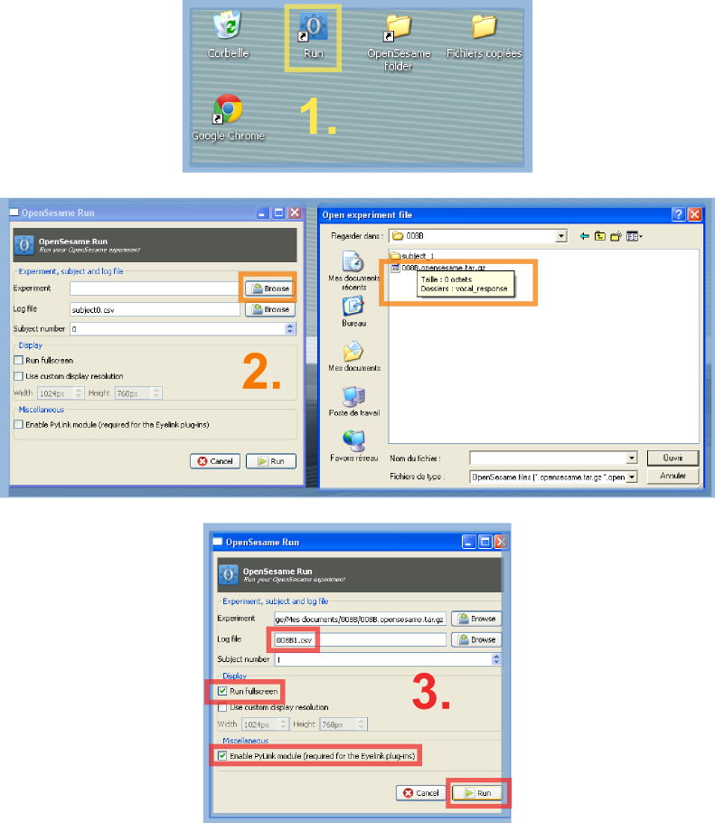Figure 1:OpenSesame menu
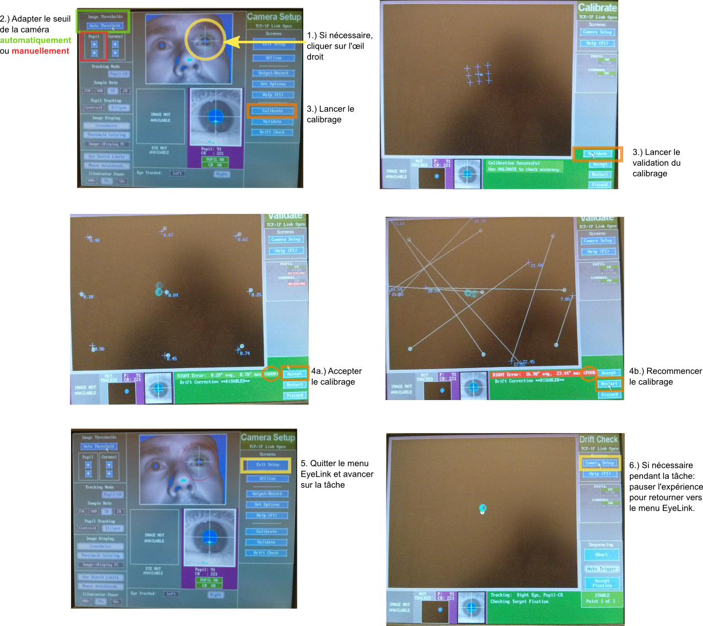Figure 2: EyeLink menu

